
PAC SUN REPORT: APRIL 8, 2011
Mitchell J. Fisher, CFP, President
www.pacsunfinancial.com

“We're in a giant car heading towards a brick wall and everyone's arguing over where they're going to sit.” David Suzuki, Scientist and Broadcaster
Is arguing about money these days becoming contagious? You have the NFL players challenging the owners about the collective bargaining agreement. Congress is on the verge of shutting the country’s economy down with their budget disputes. Actors, agents, and studio executives are punching it out in the press. State representatives are hammering the unions. Isn’t there enough money to go around for everyone? Well, I guess not. According to Money Magazine, 32% of Americans are spending less and they don’t expect that to change.

      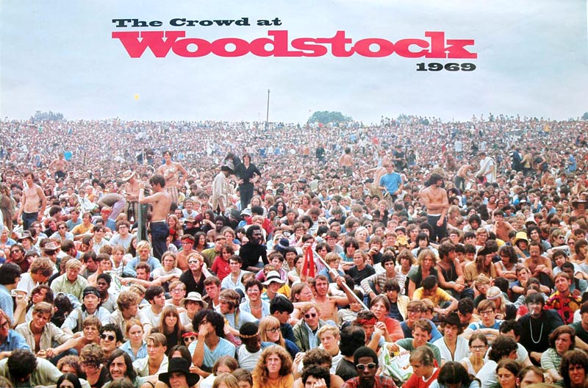
The equity markets continue to shrug off the preponderance of negative news. The tsunami-nuclear disaster in Japan, the revolutions in the Middle East, high unemployment, bank foreclosures, and soaring oil prices have not altered the upward course of stocks. The S&P 500 gained 4.8% in the first quarter of 2011 and the DOW finished higher by 742 points…the best first quarter in ten years. Home prices fell for the sixth straight month and consumer spending went up for the seventh consecutive month. The US economy added 216,000 jobs in March and the jobless rate fell to a two year low of 8.8% nationally. Year-to-date, the top sectors have been Energy +17.3%, Industrials +9.7% and Healthcare +6.2%. Small and Mid Cap funds have led the growth march by averaging more than 8% in the first quarter. On April 1st, the 30 Year Mortgage rate average was 4.92%, the price of Gold was $1418 per ounce, and the 2 Year Treasury bond was less than 1%.

Last call - IRA deposits. In order to be sure that your IRA check deposits are applied to 2010, please make sure that they arrive in our office by Thursday, April 14th.

Elizabeth Taylor left our world last month. She was truly an incredible woman in so many ways. She defined glamour and beauty in her acting career. She was the first to make $1 million for a film, won 2 Academy awards for best actress, and became well known for her diamonds and her 8 marriages. More important than any of these famous attributes and accomplishments, Liz should be most admired for her relentless contributions of time and money to charity. She has joined her co-star and fellow philanthropist Paul Newman who left us last year.

While you are in the tax mode with your accountant, you may want to discuss how the new estate and gift tax laws might apply to you. The new exemption is $5 million followed by a 35% tax rate. For couples, the revised “portability” rules for spouses will allow for $10 million to be passed on tax-free. Here are a few general ideas that are currently coming from estate planners and attorneys: 1.Make larger gifts in 2011 and 2012, 2. Pay college tuition and medical bills for loved ones, 3. Use life insurance to pay taxes, provide family income, and fund buy-sell agreements, 4. Make annual gifts of $13,000, and 5.Take advantage of discounting techniques such as Grantor Trusts, Family Partnerships, Charitable and Generation Skipping Trusts. Now should be a good time for you to pull out your own Trust documents and make sure they are up-to-date.
On a personal note: Thank you to the Moorhead and Melville families. You were the first clients to jump on our idea to save a tree and adopt a paperless world. It’s a pretty easy process that begins with a phone call or an email to us. Everything financial and much more can be viewed privately through our systems on the Internet. A special thanks to Annette Applebaum for your referral. We love to meet new people who can appreciate our service.

The senseless beating of a Giants fan at Dodger Stadium last week should be a lightning rod for immediate change. If you can’t feel safe at a baseball game, where can you go to enjoy a family sporting event? Growing up in LA and going to Chavez Ravine to watch the Dodgers brought me feelings of joy, relaxation and special times with family and friends. Years later, I recall driving into the parking lot at the Forum for a Metallica concert with my youngest son and feeling uncomfortable with the rowdy crowd. Okay…the Dodgers aren’t heavy metal, and the band was fantastic, but the idea of being threatened by random violence was unnerving. This is really nothing new. We had a similar scenario in the 60’s at Altamont with the Rolling Stones. We also had a very peaceful Woodstock. A minority of thugs and scoundrels will always exist…at public events, in politics and in the financial world. The majority should stand in their way and make the necessary changes to insure peace and security. There is no doubt that William Bratton, as he did in New York and LA, will help restore order and safety at the stadium. After he finishes that job, perhaps Wall Street and Congress will hire him, too.

“Peace is not the absence of conflict but the presence of creative alternatives for responding to conflict.” Dorothy Thompson, Journalist and Broadcaster

Speaking of peace and security, your latest statements may well provide you with feelings of calm and confidence. Most assets classes have continued to grow gradually over the past year and, in my opinion, show signs of blooming even more this spring. Needless to say, it is important to be balanced and focused on the best potential growth sectors. The world of investing is in a constant state of flux. Bond guru Bill Gross recently jettisoned all US Treasuries in his PIMCO Total Return fund. If you haven’t had a recent check-up, please make it a point to schedule a review. In addition to the performance numbers, graphs and economic discussions, I would like to know if we are meeting your expectations and in what areas we might be of more value to you.

Today’s the day.

Mitch Fisher

Pacific Sun Financial Corp; 95 Argonaut, Suite 105, Aliso Viejo, CA. 92656 Telephone: (949) 716-8646 Fax: (949) 716-8645 Website: www.pacsunfinancial.com

National Asset Management, Inc. (NAM) is a Registered Investment Advisor with the SEC. NAM provides fundamental investment management services. The views expressed contain certain forward-looking statements. NAM believes these forward-looking statements to be reasonable, although they are forecasts and actual results may be meaningfully different. Actual events may cause adjustments in portfolio management strategies. This material represents an assessment of the market at a particular time and is not a guarantee of future results. This information should not be relied upon as research or investment advice regarding any security. One cannot directly invest in an index. Index performance returns do not reflect any management fees, transaction cost or expenses. Indices are unmanaged. S&P 500 Index is an unmanaged index of 500 common stocks chosen to reflect the industries in the US economy. The DOW Jones Industrial Index is an index that shows how 30 large, publicly owned companies based in the United States have traded during a standard trading session in the stock market. Securities offered through National Securities Corporation, Member FINRA/SIPC. Investment Advisory Services offered through National Asset Management, Inc SEC Registered Advisor and affiliate of National Securities Corporation. NAM or Pacific Sun Financial does not offer any legal or tax advice. One should consider consulting with a legal or tax professional before implementing investment strategies.

MFS Investment Management 4-4-11
J.P. Morgan Asset Management 4-4-11
LA Times 3-10-11

